ALDBURY PARISH COUNCIL WARDENS UPDATE: JUNE 2025

AREA | ALLOTMENTS & MILLENNIUM ORCHARD
TO CHECK | Fencing & gates, benches, trees, hedges & shrubs, grass height, signs, footpaths, housekeeping, ground conditions
INSPECTION DATES | 30/5,06/6, 13/6, 20/6, 27/6
ISSUES TO REPORT | - Public footpaths were in good condition and well defined within the orchard.  - Most allotment plot holders are maintaining their plots to a good standard. Some instances may require additional housekeeping.  - Fences, gates, and benches were in fair condition.  - Information signs were in situ and legible.  - The grass height meets the mowing specification. The pathways and play area were mown three times this month.  - Tree Branches and overgrown vegetation is making vehicular movement problematic at the allotments (upper boundary). APC may wish to address this matter in the autumn.  Outstanding items  - A new waymarker is required for public footpath no: 6.

AREA | PLAYGROUNDS
TO CHECK | Equipment, Safety Information, Fencing & Gates, Benches, Trees, Grass height, General ground conditions, Empty litter bin.
INSPECTION DATES | 30/5,06/6, 13/6, 20/6, 27/6  Tring Station 25/06
ISSUES TO REPORT | - Both playgrounds were visually checked and remain in good condition. The following can be confirmed:  - Both playgrounds display clear and legible user and ownership information.  - The grass at Aldbury Playground was cut three times this month and at Tring Station it was cut on two occasions. Grass height is meeting the mowing specification.  - Benches are in fair condition, and gates were operational.  - The litter bin was emptied weekly.  - The rubber safety surface around the Carousel – Roundabout is worn in several places (noted in the ROSPA report). Designated as Low risk but needs to be monitored for further deterioration (Photo 1).  Outstanding Items  - A decayed fence/gatepost at the Aldbury playground, along with attached fence panel, is unsteady. APC is consulting with a local contractor to fix this issue.  - Update playground signage to meet best practice standards.  - Gaps between the rubber tiles in the swing area need closing to prevent trip hazards.

AREA | RECREATION GROUND
TO CHECK | Tennis court, Basketball area, Pavilion, Fencing, Benches/seats, Bollards, Trees & vegetation, Grass height, car park, Litter & dog waste bins, Footpaths.
INSPECTION DATES | 30/5,06/6, 13/6, 20/6, 27/6
ISSUES TO REPORT | - Grass height is meeting the specification and was mown three times this month. A good standard is being maintained.  - Weekly litter picks were conducted. Litter and dog waste bins were emptied on a weekly basis by DBC.  - Benches were seen in fair condition.  - The tennis court was seen in good order. However, APC my wish to consider the following:  - Ant infestation has caused a small hole to open on the tennis court surface (Photo 2).  - The tennis court net needs repair/replacement being threadbare in places (Photo 3).  - No new defects were seen on the trees. The last tree survey was conducted in July 2023.  - Tree branches growing over the basketball area have been successfully cut back.  Outstanding items  - A dead tree is leaning against another tree and needs to be removed. The clerk is organizing its removal.  - The entrance to the car park requires surface and pothole repairs.  - Graffiti removal is required from the sports pavilion wall to deter additional occurrences.  - A public footpath sign needs to be reinstated (public footpath no: 27).

AREA | VILLAGE GREEN(S) & POND
TO CHECK | Benches, Trees, Pond, Grass height, Stocks, Litter Bins, Notice board.
INSPECTION DATES | 30/5,06/6, 13/6, 20/6, 27/6
ISSUES TO REPORT | - The benches were observed in good condition.  - No visible defects were observed on the trees. Some dead wood noted lying on the ground.  - The grass areas were mowed three times this month. A well-maintained and orderly appearance continues to be upheld.  - DBC emptied the litter bins on a weekly basis.  - Weekly litter picking was conducted. Low level of litter.  - The notice board was well-maintained. Information displayed was current and relevant.  - A wooden post has been knocked over by a motor vehicle and needs reinstating (Photo 4).

AREA | HIGHWAY’S, PUBLIC FOOTPATHS & DITCHES
TO CHECK | Surfaces, Pedestrian routes, Signage, Drainage, Grit bins, Litter, Street lamps, Bollards, kissing gates, Notice board (Tring Station)
INSPECTION DATES | 30/5,06/6, 13/6, 20/6, 27/6
ISSUES TO REPORT | - Overgrown hedges in Station Road between Clarkes Spring and the railway station were cut back from the pathway by HCC. Ref No: 401004669536.  - A visual check of the streetlights was conducted on the 30th of June. No additional defects were identified to be added to the existing list of outstanding items below.  - Litter picking was conducted along Stocks Road (to the parish boundary), New Ground Road (to the GUC bridge), Malting Lane, Stonycroft and Toms Hill to FP15.  - The drainage ditch south of Stonycroft appears clear, but dense summer vegetation hinders a close inspection.  - HCC have repaired two potholes in New Ground Road. Ref No’s 401004677655 and 401004677656 (Photos 5 & 6).  - A new notice board has been installed in Tring Station (Photo 7).  Outstanding Items  - Reinstatement of waymarker in Hitchins Field (public footpath no:63).  - Replacement of a decayed street nameplate on Toms Hill. This has been added to DBC replacement list. Ref No: 895084.  - Restore streetlighting at the Recreation Ground entrance, opposite the Church, Malting Lane junction, and near Beechwood Drive junction.  - Two faded SLOW road marking on Toms Hill and station Road to be repainted, HCC Ref No’s: 401004654989 and 401004654999.  - Overgrown shrubbery in Trooper Road is yet to be cut back by a resident, despite receiving an APC advisory letter.

PHOTOGRAPHS
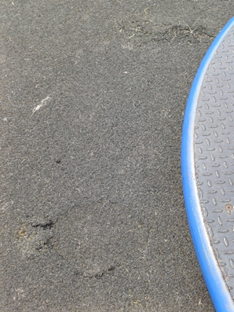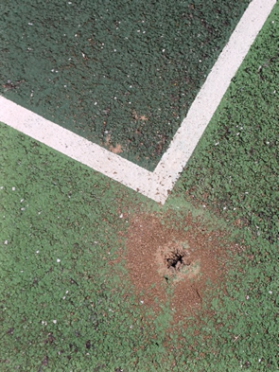
3
1
2

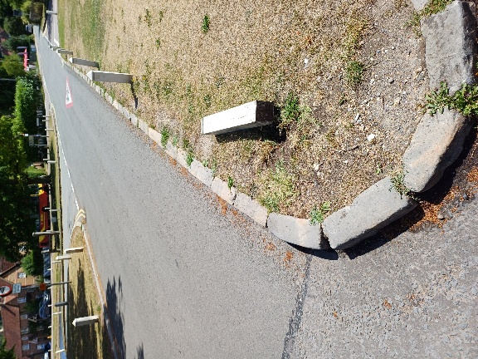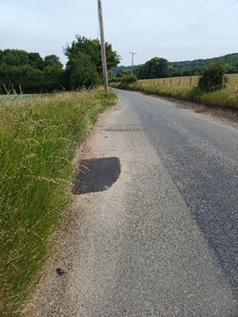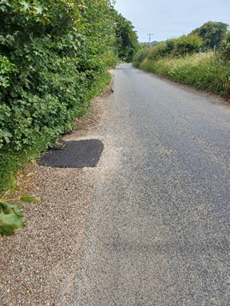
6
5
4

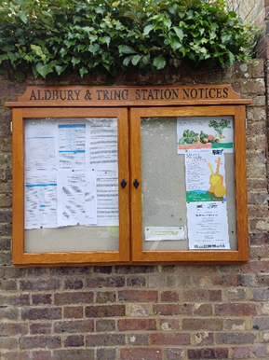
7

